**Color Detector - Build Instruction**

1. **Items (Shipping fee included):**

* Raspberry Pi - $112
* Color Sensor TCS34725 - $15
* Temperature Sensor TMP007 - $36
* ADS1115 16-Bit ADC - $8
* Solar panel - $15
* Pi cobbler - $20

Total Cost - $206

The following components were provided by the prototype lab:

* Printed Circuit Board
* Connectors
* Header Pins
* Soldering equipment

1. **Schedule:**

PCB Design:

About 1 day to design and 3 day to get PCB printed from the prototype lab.

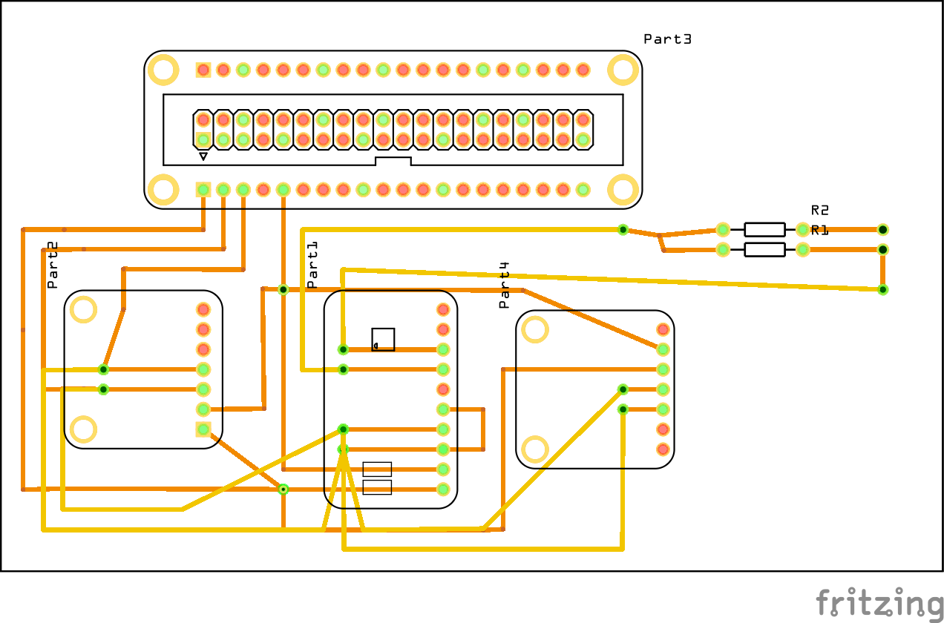

Soldering and RPI connection

Approximately 2 hours were spent to de-solder and solder all parts into one.

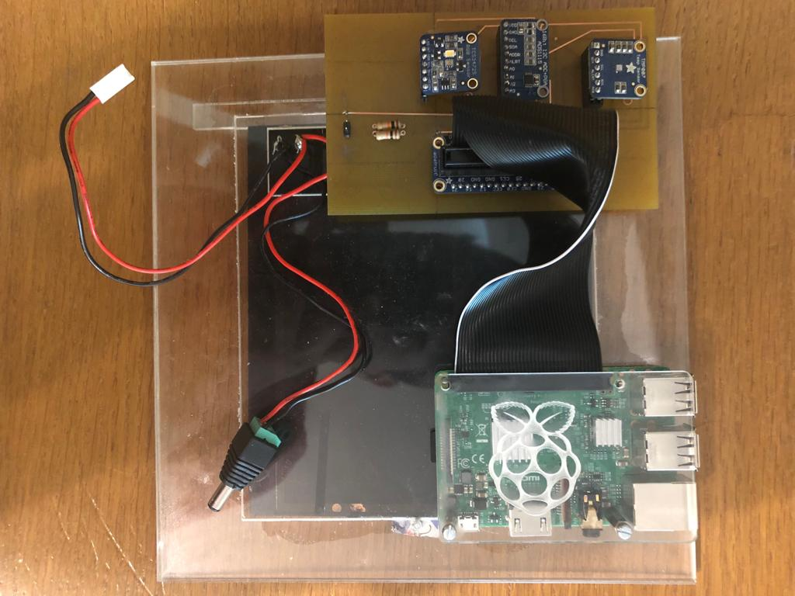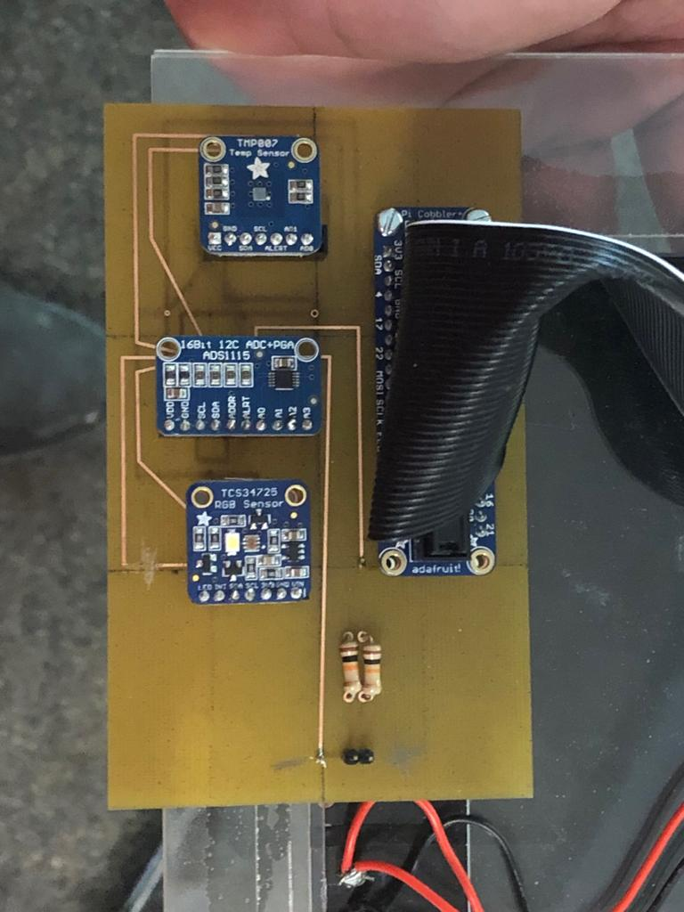Enclosure

Total time: 4 to 5 days to complete the hardware since enclosure was already done.

1. **Database set up and the structure of the database**

To set up the Firebase database, python library was installed on both hardware and software.

Based on the sensors, there are 3 main data types to store on Firebase: color hex value, temperature value and voltage value. Other data such as timestamp was also added to keep track on the latest value from the sensor. Below is a diagram of the data structure.

The main node represents the User ID and nodes under it represents data that keeps on updating.

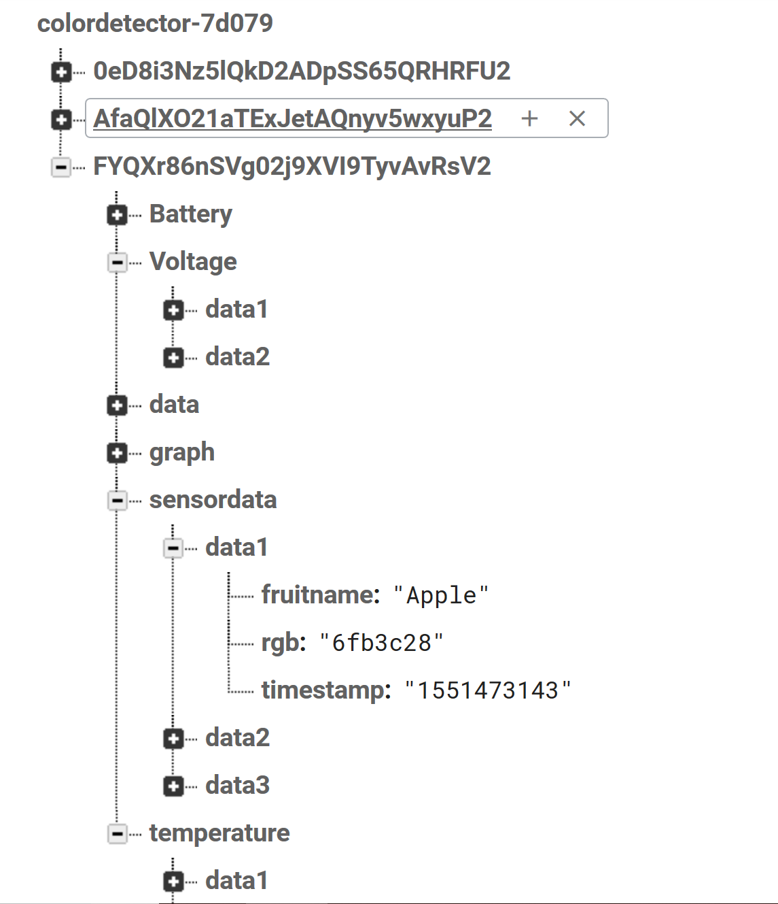

1. **The configuration of the hardware and software, including your PI and the database:**

Hardware: Install python library to communicate with Firebase database. To connect to computer, network sharing must be turned on so that the raspberry pi can be recognized and be able to access the internet. (Retrieved from <https://pypi.org/project/python-firebase/>) and installed on the raspberry pi.

Software: Install Firebase SDK and set up real time-database on the Firebase platform website. (Retrieved from: <https://firebase.google.com/docs/android/setup>)

1. **The Android APP building instructions and compiling, running environments.**

The building instructions for app is included in the github.

Android Studio was used as a compiling and running environment to write the application. The application was then installed on android smartphone and data would synchronize between the app and the database.

1. **Project testing:**

Basically, the hardware is powered on and connected to computer through an Ethernet cable and the user can access the command prompt interface over the network. To test the sensors, python program needs to be run then the sensors will send data reading to Firebase. In case it does not run as expected, run the “sudo i2cdetect -y 1” to check if all three addresses are present.

All the connections must be accurate and secured. The data will be pushed into Firebase and retrieved from the app.

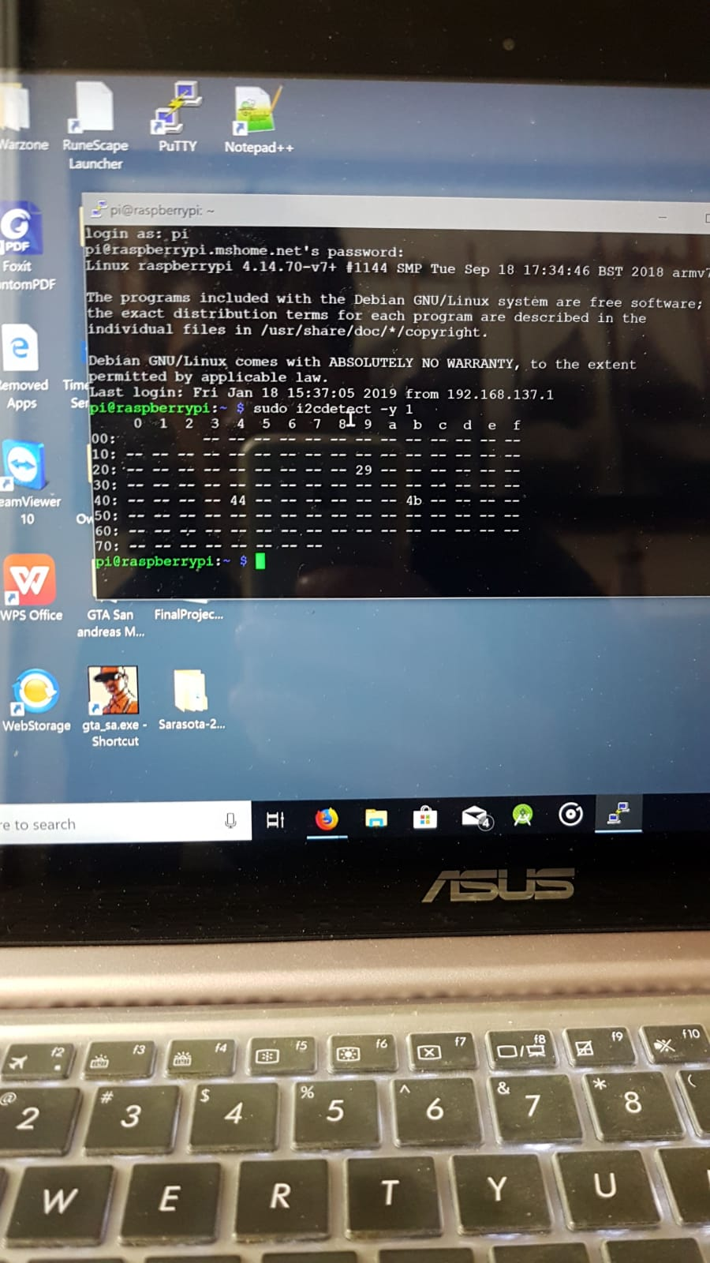

1. **References:**

<https://firebase.google.com/docs/android/setup>

<https://pypi.org/project/python-firebase/>

<https://developer.android.com/studio>